**Forecasting- Airline Dataset**

**Visualization shows that it has level, trend and fluctuate with seasonality change.**

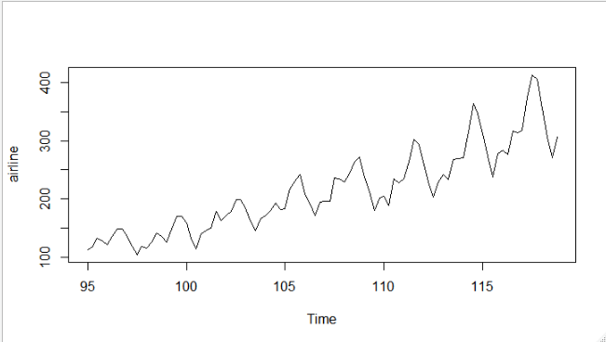

**Using HoltWinters Function 🡺**

**Optimum values with alpha = 0.2 which is default value assuming time series data has only level parameter**

**Alpha = level smoothing, Beta = Trend smoothing, Gama = Seasonality Smoothing**

Smoothing parameters:

alpha: 0.2

beta : FALSE

gamma: FALSE

Coefficients:

[,1]

a 297.4342

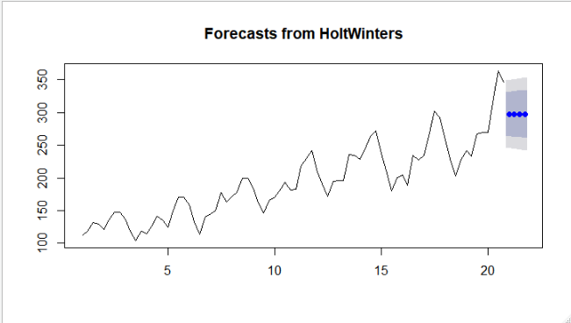

**By looking at plot the forecasted values are not showing any characters of train data.**

**Optimum values with alpha =0.2, beta=0.1 assuming time series data has level and trend parameter.**

Smoothing parameters:

alpha: 0.2

beta : 0.1

gamma: FALSE

Coefficients:

[,1]

a 306.834206

b 5.673007

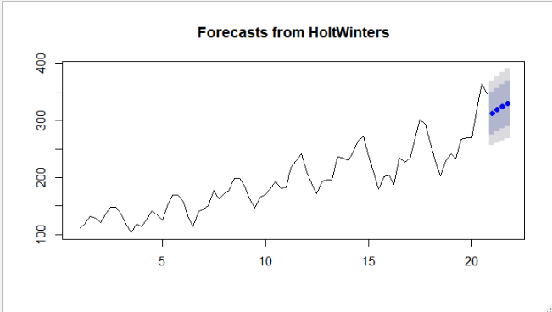

By looking at the plot the forecasted values are still missing some characters exhibited by train data.

**Optimum values with alpha =0.2, beta =0.1, gamma=0.1 assuming time series data has level, trend and seasonality.**

Smoothing parameters:

alpha: 0.2

beta : 0.1

gamma: 0.1

Coefficients:

[,1]

a 308.334502

b 5.589123

s1 -5.261337

s2 -3.828212

s3 8.342981

s4 7.353062

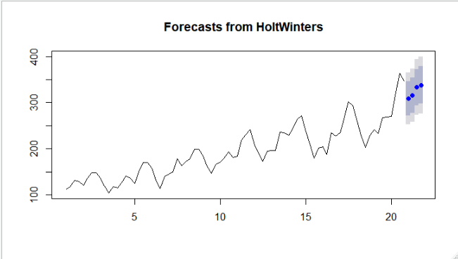

**By looking at the plot the characters of forecasted values are closely following historical data.**

**Without Optimum Values🡺**

Smoothing parameters:

alpha: 0.9999339

beta : FALSE

gamma: FALSE

Coefficients:

[,1]

a 347.0011

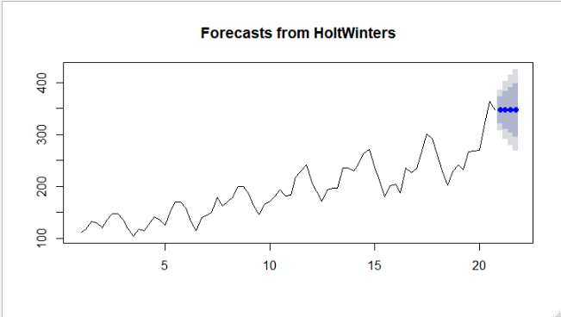

Smoothing parameters:

alpha: 1

beta : 0.005491927

gamma: FALSE

Coefficients:

[,1]

a 347.000000

b 5.008211

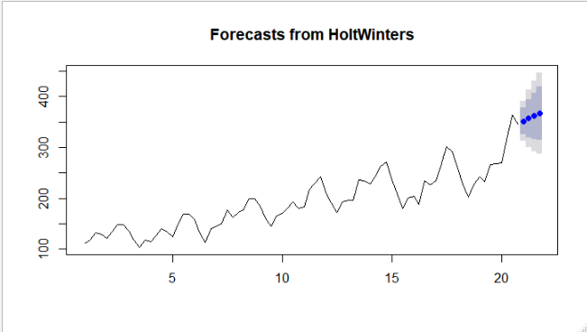

Smoothing parameters:

alpha: 1

beta : 0

gamma: 0

Coefficients:

[,1]

a 344.90625

b 3.93750

s1 -10.03125

s2 -0.40625

s3 8.34375

s4 2.09375

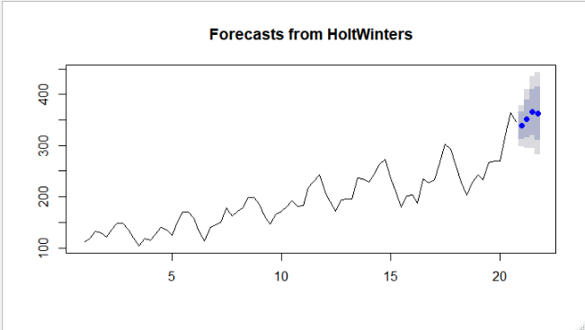

**By looking at the plot the characters of without optimum forecasted values are closely following historical data.**